**Ride Sharing App with Driver and Rider**

Project submitted to the

SRM University – AP,Andhra Pradesh

Submitted in partial fulfillment of the requirement for the award of the degree of

**Bachelor of Technology**

**in**

**Computer Science and Engineering**

**School of Engineering and sciences**

**Submitted By**

Karthikeya Ganesh Cheedella(AP23110010592)

Lokesh Polisetty(AP23110010630)

Vamsi Krishna Reddy Yekkanti(AP23110010639)

Tharun Jammula (AP23110010644)

Under the guidence of

**Ms V.Veda sri**



**Department of Computer Science and Engineering**

**SRM University-AP**

**Neerukonda, Mangalagiri, Guntur**

**Andhra Pradesh – 522 240**

**[November,2024]**

**Department of Computer Science and Engineering**

SRM University,AP



**CERTIFICATE**

This is to certify that the Project report entitled **“Ride Sharing App with Driver and Rider”** is being submitted by Cheedella karthikeya ganesh (AP23110010592)**,** a student of Department of Computer Science and Engineering, SRM University,AP, in partial fulfillment of the requirement for the degree of **“B.Tech(CSE)”** carried out by her/his during the academic year 2024-2025.

Signature of the Supervisor Signature of Head of the Dept.

**Department of Computer Science and Engineering**

SRM University,AP



**CERTIFICATE**

This is to certify that the Project report entitled **“Ride Sharing App with Driver and Rider”** is being submitted by Polisetty Lokesh (AP23110010630)**,** a student of Department of Computer Science and Engineering, SRM University,AP, in partial fulfillment of the requirement for the degree of **“B.Tech(CSE)”** carried out by her/his during the academic year 2024-2025.

Signature of the Supervisor Signature of Head of the Dept.

**Department of Computer Science and Engineering**

SRM University,AP



**CERTIFICATE**

This is to certify that the Project report entitled **“Ride Sharing App with Driver and Rider”** is being submitted by Vamsi Krishna Reddy Yekkanti(AP23110010639)**,** a student of Department of Computer Science and Engineering, SRM University,AP, in partial fulfillment of the requirement for the degree of **“B.Tech(CSE)”** carried out by her/his during the academic year 2024-2025.

Signature of the Supervisor Signature of Head of the Dept.

**Department of Computer Science and Engineering**

SRM University,AP



**CERTIFICATE**

This is to certify that the Project report entitled **“Ride Sharing App with Driver and Rider”** is being submitted by Tharun Jammula (AP23110010644)**,** a student of Department of Computer Science and Engineering, SRM University,AP, in partial fulfillment of the requirement for the degree of **“B.Tech(CSE)”** carried out by her/his during the academic year 2024-2025.

Signature of the Supervisor Signature of Head of the Dept.

**Acknowledgement**

The satisfaction that accompanies the successful completion of any task would be incomplete without introducing the people who made it possible and whose constant guidance and encouragement crowns all efforts with success.

I am extremely grateful and express my profound gratitude and indebtedness to my project guide,**V.Veda sri**, Department of Computer Science & Engineering, SRM University,Andhra pradesh, for her kind help and for giving me the necessary guidance and valuable suggestions in completing this project work.

Cheedella karthikeya ganesh

(AP23110010592)

**Acknowledgement**

The satisfaction that accompanies the successful completion of any task would be incomplete without introducing the people who made it possible and whose constant guidance and encouragement crowns all efforts with success.

I am extremely grateful and express my profound gratitude and indebtedness to my project guide,**V.Veda sri**, Department of Computer Science & Engineering, SRM University,Andhra pradesh, for her kind help and for giving me the necessary guidance and valuable suggestions in completing this project work.

Lokesh Polisetty

(AP23110010630)

**Acknowledgement**

The satisfaction that accompanies the successful completion of any task would be incomplete without introducing the people who made it possible and whose constant guidance and encouragement crowns all efforts with success.

I am extremely grateful and express my profound gratitude and indebtedness to my project guide,**V.Veda sri**, Department of Computer Science & Engineering, SRM University,Andhra pradesh, for her kind help and for giving me the necessary guidance and valuable suggestions in completing this project work.

Vamsi Krishna Reddy Yekkanti

(AP23110010639)

**Acknowledgement**

The satisfaction that accompanies the successful completion of any task would be incomplete without introducing the people who made it possible and whose constant guidance and encouragement crowns all efforts with success.

I am extremely grateful and express my profound gratitude and indebtedness to my project guide,**V.Veda sri**, Department of Computer Science & Engineering, SRM University,Andhra pradesh, for her kind help and for giving me the necessary guidance and valuable suggestions in completing this project work.

Tharun Jammula

(AP23110010644)

### **Abstract:**

The Ride Booking Application is a C++-based system designed to provide an efficient and secure platform for managing ride services. It addresses the need for a streamlined ride-booking experience by enabling users to register, log in, and book rides while allowing drivers to register and update their availability. Administrators are provided with tools to oversee user and driver data as well as trip details.

The system employs a modular approach with key components such as the **UserAccount**, **BookRide**, and **Admin** classes. User data is securely handled using file-based storage, ensuring accessibility and simplicity. Password security is enhanced through masked input during login and registration processes. The **UserAccount** class facilitates user and driver management, while the **BookRide** class ensures seamless ride-booking operations. The **Admin** class provides administrative functionalities, including data validation and report generation.

During implementation, special care was taken to manage input errors, enhance user experience, and handle data through text files, ensuring the application remains lightweight and efficient. The use of file I/O for storing and retrieving credentials and ride data ensures data persistence without requiring a database.

The project concludes that a C++-based ride booking system is viable for small-scale applications, offering simplicity and portability. Future work could involve integrating real-time database management and a graphical user interface for enhanced usability.

**Table of Contents**

1. Introduction .................................................................Pg.no→12

2. Literature Review .......................................................Pg.no→13

3. Problem Statement .....................................................Pg.no→15

4. Objectives ....................................................................Pg.no→17

5. Methodology ..............................................................Pg.no→19

6. Implementation .........................................................Pg.no→21

7. Results and Analysis ................................................Pg.no→24

8. Discussion ..................................................................Pg.no→28

9. Conclusion .................................................................Pg.no→30

10. Future Scope ............................................................Pg.no→31

11. References ................................................................Pg.no→33

### **1. Introduction**

#### **1.1 Background:**

The Ride Booking Application was developed to address the growing need for convenient and reliable ride-booking systems in today's fast-paced digital world. With the increasing reliance on on-demand ride services, it has become essential to provide a robust platform for managing users, drivers, and rides efficiently. By leveraging C++ programming, this project showcases how object-oriented design and file-based data storage can be used to build a functional system for ride management.

#### **1.2 Significance and Context:**

This project holds significance as it demonstrates a lightweight and scalable approach to managing a ride-booking system. Unlike database-dependent applications, the Ride Booking Application employs text files for data storage, ensuring simplicity and portability. The system emphasizes modularity, security, and usability, making it suitable for small-scale applications or as a prototype for more complex systems. It serves as a practical example of applying C++ principles to solve real-world problems while addressing common challenges like user authentication, ride allocation, and administrative control.

#### **1.3 Scope and Purpose:**

The project is designed to support three primary operations:

* **User Operations**: Includes user and driver registration, secure login, password recovery, and ride booking.
* **Driver Operations**: Focuses on driver registration, login, and availability management.
* **Administrative Functions**: Offers features for administrators to validate user and driver data, oversee trips, and ensure system integrity.

The purpose of this project is to deliver an efficient and secure ride-booking platform while showcasing the versatility of C++ in building real-world applications. It also provides a foundation for potential enhancements, such as integration with real-time databases and graphical user interfaces for broader use cases.

### **2. Literature Review**

#### **2.1 Previous Research and Related Projects:**

Ride-booking systems, such as Uber and Ola, have revolutionized transportation by leveraging technology to connect drivers and passengers. These platforms typically use robust database systems, mobile applications, and real-time GPS tracking to enhance user experience. Research in this domain highlights the importance of user-friendly interfaces, secure authentication systems, and efficient ride allocation algorithms to ensure system reliability and customer satisfaction.

In academic and project-based scenarios, smaller-scale ride-booking systems often employ modular programming and file-based storage to simulate functionality without the complexity of a full-stack implementation. Studies have demonstrated the effectiveness of modular design in maintaining scalability and improving code readability in applications like hotel reservations and ticket booking systems.

#### **2.2 Relevant Technologies and Approaches:**

This project builds on established techniques in:

* **File-Based Data Management**: The system uses text files for storing user credentials, trip details, and driver lists. This approach is well-documented for its simplicity and portability, particularly in resource-constrained environments.
* **Secure Input Handling**: Masked password inputs, as implemented in the **UserAccount** class, are an adaptation of secure input techniques often used in web-based systems.
* **Distance Calculation APIs**: The integration of the GoMaps API to retrieve geocoding and distance information demonstrates how external services can enhance application functionality, similar to how ride-hailing giants leverage Google Maps APIs for navigation.

#### **2.3 Gaps Addressed by the Project:**

While existing literature and projects focus on comprehensive ride-booking systems with complex integrations, they often overlook lightweight implementations for educational or prototype purposes. This project bridges that gap by offering a simplified yet functional system using only C++ and file-based storage. Additionally, it highlights:

* The use of modular design to ensure maintainability and scalability.
* Integration of APIs within a basic C++ application for geolocation services.
* Emphasis on secure and user-friendly input handling, addressing the need for lightweight security measures in small-scale applications.

By addressing these gaps, the project contributes a practical framework for understanding the fundamentals of ride-booking systems, serving as a foundation for further academic exploration and development.

### **3. Problem Statement**

#### **3.1 Identifying the Problem:**

The need for efficient, secure, and user-friendly ride-booking systems has grown significantly with the rise of on-demand transportation services. However, existing platforms like Uber and Ola rely on sophisticated infrastructures, including real-time databases, GPS systems, and mobile applications. For developers and learners aiming to build and understand such systems, the complexity of these platforms poses a significant challenge. A lightweight alternative is needed to simulate the functionality of ride-booking applications without the overhead of advanced technologies.

Additionally, many existing systems lack provisions for resource-constrained environments or scenarios where database integration is infeasible. This creates a gap in providing scalable and simple solutions for small-scale use cases or educational purposes.

**3.2 Importance of the Problem:**

The problem is significant in the fields of education, software prototyping, and resource-limited applications. Aspiring developers, students, and researchers often require simplified systems to understand the core functionalities of ride-booking platforms, such as user authentication, ride allocation, and trip management. A system built using C++ with file-based storage addresses this need effectively, providing a practical tool for learning and experimentation.

Moreover, secure handling of user data, efficient driver allocation, and seamless integration of external services (e.g., distance calculation APIs) are critical features in real-world applications. Addressing these aspects in a lightweight application ensures that even minimalistic systems maintain a high standard of usability and reliability.

#### **3.3 Scope of the Problem:**

This project specifically targets the following challenges:

1. **Simplified Data Management**: Implementing a file-based approach to manage users, drivers, and trip data while maintaining data integrity.
2. **Secure Authentication**: Providing a secure mechanism for user and driver login, including password masking and password recovery features.
3. **Efficient Ride Allocation**: Assigning drivers dynamically based on availability and user preferences, ensuring a smooth booking experience.
4. **Integration with APIs**: Using external geocoding and distance APIs to enhance ride-booking functionality without the need for complex database systems.

By solving these problems, the project demonstrates how fundamental programming principles can be applied to create a functional prototype of a ride-booking system, paving the way for future enhancements and real-world applications.

### **4. Objectives**

#### **4.1 To Develop a Functional Ride-Booking System:**

The primary objective of this project is to design and implement a functional ride-booking system using C++. The system aims to simulate real-world features such as user and driver registration, ride allocation, and trip management. By incorporating modular programming, the application ensures that each functionality is handled by specialized components, enhancing code readability and maintainability.

**4.2 To Provide Secure User and Driver Management:**

The project seeks to implement secure mechanisms for managing users and drivers. This includes:

* User and driver registration with data stored in individual text files for portability and simplicity.
* Secure login functionality using password masking to protect user credentials.
* Password recovery options to assist users and drivers in retrieving forgotten credentials.

#### **4.3 To Enable Efficient Ride Booking and Trip Management:**

The system is designed to allow users to book rides seamlessly and assign available drivers dynamically. Key features include:

* Distance calculation using the GoMaps API for precise fare computation.
* Dynamic driver allocation based on availability and user confirmation.
* Fare calculation with tiered pricing and discounts based on distance and ride type.

#### **4.4 To Facilitate Administrative Oversight**

The project includes administrative functionalities for managing and validating system data. Objectives under this goal include:

* Allowing administrators to search for and review user and driver records.
* Viewing and managing trip details stored in text files for auditing purposes.

#### **4.5 To Provide a Lightweight, Scalable Framework:**

The project aims to demonstrate how a lightweight framework using file-based storage and modular programming can be a viable alternative to complex database systems. This provides a foundation for future enhancements, such as integrating graphical interfaces or real-time databases.

### 

### 

### **5. Methodology**

#### **5.1 Modular Design Approach:**

The project employs a modular design, dividing the system into distinct classes and components for ease of development and maintainability. Key classes include:

* **UserAccount**: Handles user and driver registration, login, password recovery, and credential storage.
* **BookRide**: Manages ride booking, driver allocation, fare calculation, and trip details storage.
* **Admin**: Oversees system operations, including user and driver data validation and trip auditing.

Each class is designed to handle specific functionalities, ensuring a clear separation of concerns and simplifying debugging and future enhancements.

#### **5.2 File-Based Data Management:**

Text files are used for data storage to ensure simplicity and portability. The following files manage application data:

* **User and Driver Files**: Store user and driver credentials (e.g., username(User).txt).
* **Driver List File**: Maintains a dynamic list of available drivers (DriverList.txt).
* **Trip Details File**: Logs trip records, including user and driver information, origin, destination, distance, and fare (trip_details.txt).

This approach eliminates the need for a database, making the system lightweight and suitable for resource-constrained environments.

**5.3 External API Integration:**

The project integrates the GoMaps API to enhance functionality:

* **Geocoding API**: Converts user-provided locations into geographic coordinates.
* **Distance Matrix API**: Calculates the distance between two locations, which is critical for determining ride fares.

These APIs are accessed using the **cURL** library and the JSON parsing library **nlohmann/json**, enabling seamless data retrieval and processing.

**5.4 Algorithms and Features:**

Key algorithms and techniques include:

* **Input Validation**: Ensures robustness by checking and sanitizing user input, especially for numeric entries and formatted data (e.g., account numbers and CVVs).
* **Dynamic Driver Allocation**: Iterates through available drivers in the list to assign a suitable driver based on user confirmation.
* **Fare Calculation**: Applies tiered pricing based on vehicle type and distance, with dynamic discount application for higher fares.

#### **5.5 Justification for Methods:**

* **C++ Programming Language**: Chosen for its efficiency, flexibility, and suitability for object-oriented programming.
* **File-Based Storage**: Selected for its simplicity, avoiding the complexity of setting up and managing a database.
* **API Integration**: Incorporating APIs allows the system to simulate real-world features, such as geolocation and distance computation, enhancing user experience.

This methodology ensures a balance between simplicity and functionality, making the project practical for educational purposes and scalable for future developments.

### 

### **6. Implementation**

#### **6.1 Development Workflow:**

The implementation of the Ride Booking Application was carried out in the following steps:

1. Class Design:
   * The system was divided into key modules: UserAccount, BookRide, and Admin classes, each handling specific responsibilities.
   * Helper functions like getCoordinates() and getDistance() were implemented in the Distance class using the GoMaps API.
2. File-Based Data Handling:
   * Text files were created to store and retrieve user and driver credentials (DriverList.txt, username(User).txt).
   * Trip details were logged in a central file (trip_details.txt) to maintain a history of all rides.
3. API Integration:
   * The cURL library was used to send HTTP requests to the GoMaps Geocoding and Distance Matrix APIs.
   * The JSON library nlohmann/json was used to parse API responses and extract relevant data.
4. Input Validation and Security:
   * User input was validated to handle errors and unexpected entries.
   * Password masking was implemented in the getPasswordInput() function to ensure secure login and registration.

#### **6.2 Implementation Workflow:**

The workflow of the system is as follows:

1. **Main Menu**:
   * Displays options for Admin, User, and Exit.
   * Redirects users to their respective menus based on selection.
2. **Admin Menu**:
   * Allows the administrator to log in and view user/driver data or trip details.
3. **User Menu**:
   * Facilitates user/driver registration and login.
   * Enables users to book rides by providing origin and destination, calculating fare, and assigning drivers dynamically.
4. **Ride Booking**:
   * The BookRide class calculates the distance between two locations using the GoMaps API and computes the fare based on vehicle type.
   * Available drivers are dynamically allocated, and payment is processed via cash or online options.

**5. Flow chart:**

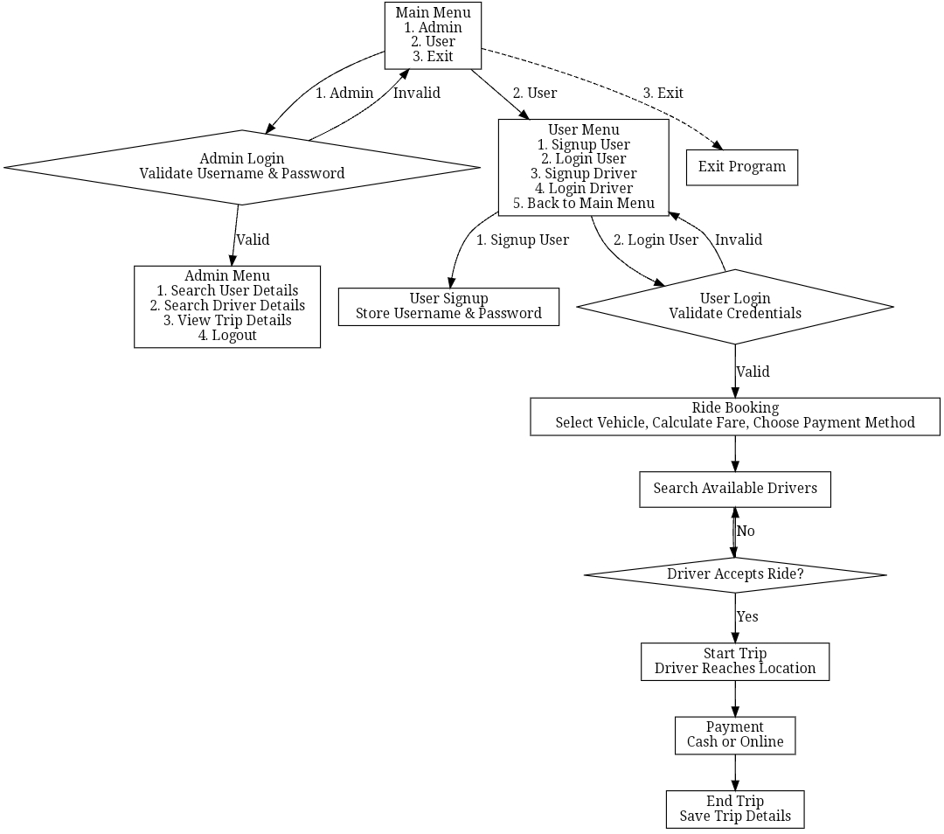

#### 

#### 

#### 

#### **6.3 Challenges and Solutions:**

**1. Input Handling and Validation:**

* Challenge: Handling invalid inputs, such as incorrect data formats.
* Solution: Implemented input validation using functions like std::cin.clear() and regular expressions for specific formats (e.g., CVV and account numbers).

**2. File Management:**

* Challenge: Ensuring data consistency and preventing file corruption.
* Solution: Used robust error handling during file operations and ensured proper file closure after each operation.

**3. API Integration:**

* Challenge: Parsing JSON responses from the GoMaps API and handling edge cases where data was unavailable.
* Solution: Used exception handling to manage JSON parsing errors and fallback mechanisms for empty responses.

**4. Driver Allocation:**

* Challenge: Dynamically assigning available drivers while handling user rejections.
* Solution: Implemented a loop to iterate through available drivers and prompt the user for confirmation or retry.

By addressing these challenges, the project was successfully implemented, demonstrating the practical use of C++ programming in building a lightweight yet functional ride-booking system.

### 

### 

### 

### 

### **7. Results**

**7.1 Driver login:**

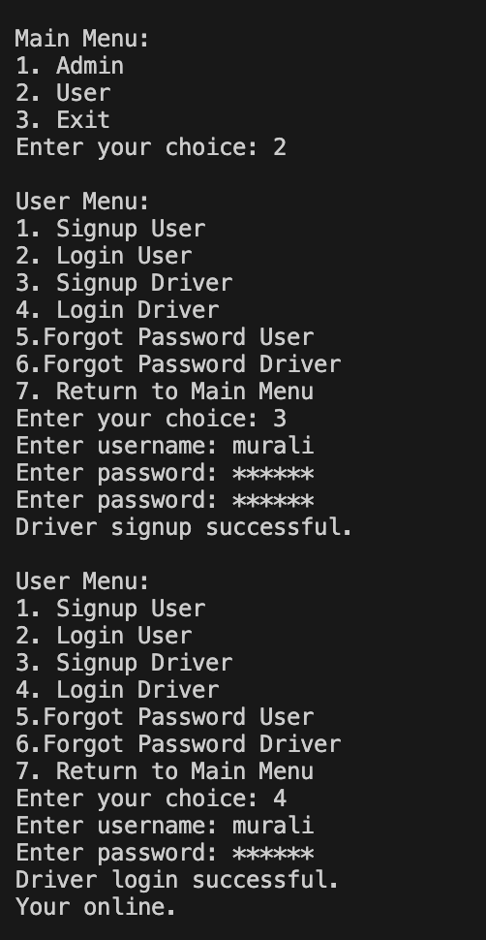

### 

### **7.2 User login:**

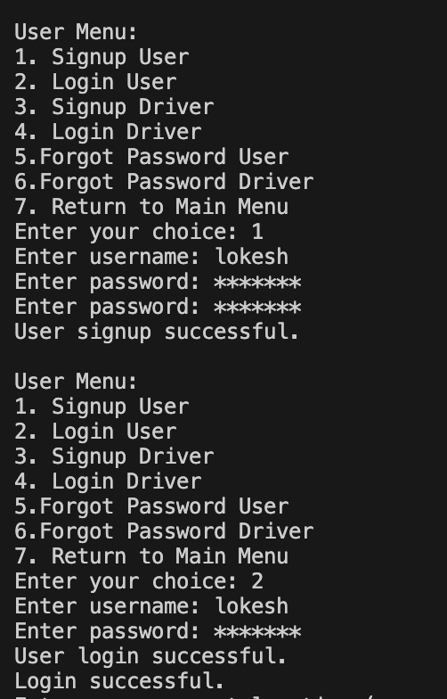

### 

### 

### **7.3 Ride Booking:**

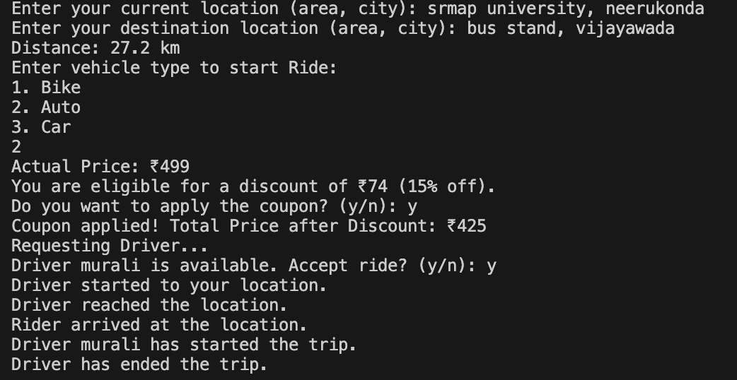

### **7.4 Payment Method:**

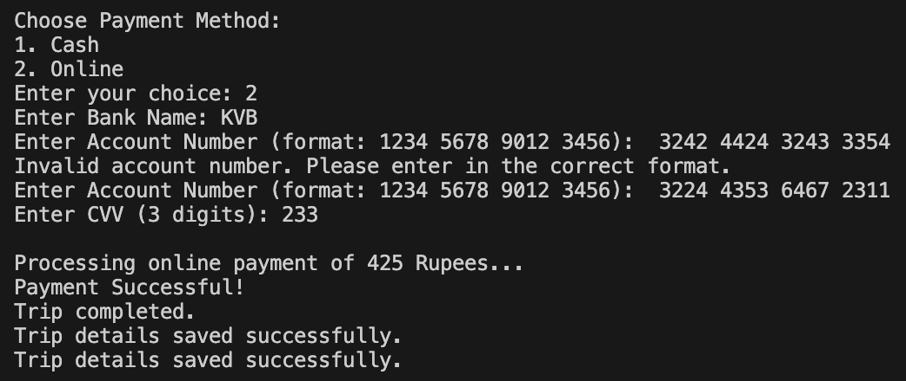

### **7.5 forgot Password:**

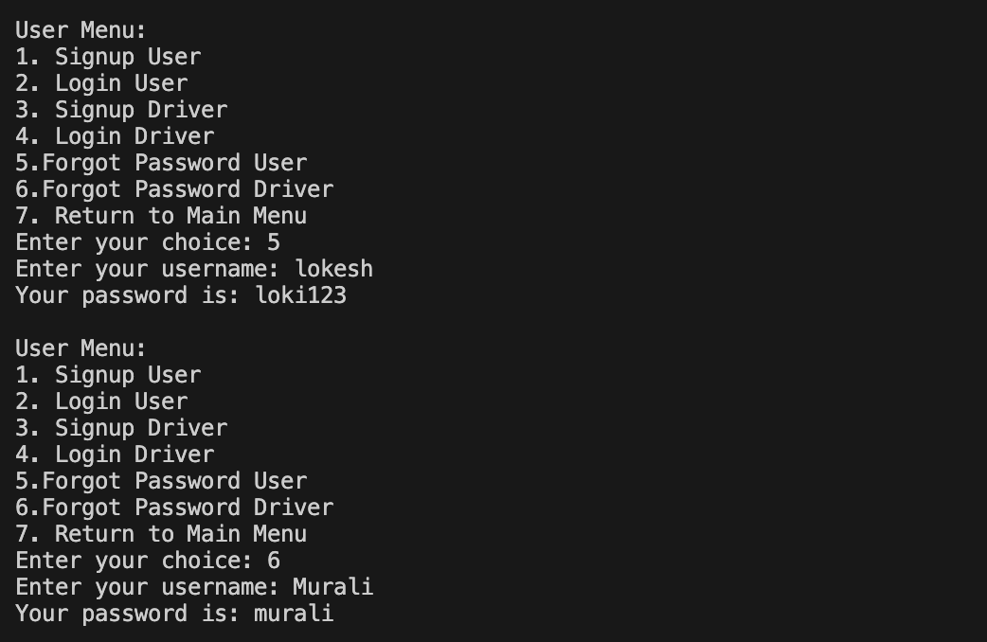

### **7.6 Admin login:**

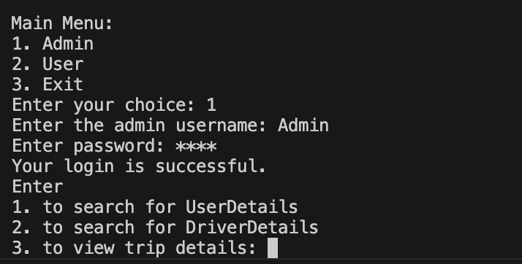

### **7.7 Admin Access:**

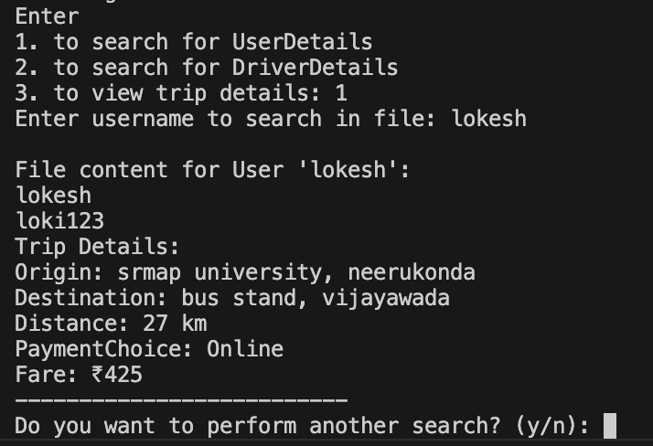

### 

### 

### 

### **8. Discussion**

#### **8.1 Comparison to Initial Objectives:**

**The Ride Booking Application successfully achieved its primary objectives:**

1. **User and Driver Management:** The system implemented secure registration, login, and password recovery features for both users and drivers, meeting the objective of secure data handling.
2. **Ride Booking:** Integration of the GoMaps API allowed accurate distance calculation and fare computation, ensuring efficient ride allocation and pricing.
3. **Administrative Oversight:** The Admin module enabled comprehensive monitoring of user, driver, and trip data, fulfilling its intended purpose.

The results validate the hypothesis that a lightweight, file-based system can provide core functionalities of a ride-booking platform while maintaining simplicity and usability. However, scalability and advanced features such as real-time updates were beyond the scope of this implementation.

#### **8.2 Implications of Findings:**

**The project demonstrates that:**

1. **Modularity Enhances Maintainability:** Dividing the system into separate classes (UserAccount, BookRide, Admin) ensured better organization and facilitated debugging and feature extension.
2. **API Integration Extends Functionality:** Using the GoMaps API added a layer of realism to the ride-booking process, showcasing the potential of external services to enhance basic applications.
3. **File-Based Systems are Practical for Small-Scale Use:** For resource-constrained environments or prototypes, text files provide a straightforward and effective data management solution.

These findings imply that similar small-scale systems can be developed for educational purposes or as proofs-of-concept for larger applications.

#### **8.3 Limitations and Sources of Error:**

**While the project met its objectives, certain limitations and potential sources of error were identified:**

1. **File-Based Storage:**
   * **Limitation:** File-based systems are not optimized for large datasets. As the number of users, drivers, and trips increases, search and retrieval operations may become slow and cumbersome.
   * **Potential Error:** File corruption or concurrent access conflicts could lead to data loss or inconsistencies.
2. **API Dependency:**
   * **Limitation:** The reliance on the GoMaps API for geocoding and distance calculation means the system is dependent on an external service.
   * **Potential Error:** Network issues or API failures could result in incomplete or inaccurate data, impacting fare calculations and ride booking.
3. **Input Handling:**
   * **Limitation:** The application requires precise user input formats for locations and payment details, which may lead to errors if users deviate from expected formats.
   * **Potential Error:** Invalid inputs might cause the program to loop or produce unexpected results.
4. **Scalability:**
   * **Limitation:** The system was designed for small-scale use. Scaling to accommodate real-time updates, multiple concurrent users, or larger datasets would require significant architectural changes.
5. **Security:**
   * **Limitation:** While password masking enhances user security, text files storing passwords in plain text are vulnerable to unauthorized access.
   * **Potential Error:** Compromised files could expose sensitive user data, necessitating encryption mechanisms in future iterations.

These limitations underscore the need for further enhancements, such as integrating a database for data management, improving error handling, and adopting encryption for sensitive information. Despite these constraints, the project provides a functional foundation for understanding the core principles of ride-booking systems.

### 

### **9. Conclusion**

#### **9.1 Summary of the Project:**

The Ride Booking Application was successfully developed as a functional prototype using C++ and file-based storage. The project demonstrated essential features of a ride-booking system, including user and driver management, dynamic ride booking, and administrative oversight. Integration with the GoMaps API enabled realistic distance calculation and fare determination, while modular design principles ensured maintainability and scalability. The system effectively handled data using text files, offering a lightweight alternative to database-driven solutions.

**9.2 Significance of the Findings:**

The findings highlight the viability of implementing a simplified ride-booking system in a resource-constrained environment. The project demonstrates:

* How modular programming enhances system organization and scalability.
* The practicality of file-based data management for small-scale applications.
* The potential of integrating external APIs to extend functionality, even in basic applications.

By addressing common challenges such as secure authentication, efficient ride allocation, and user-friendly interfaces, the project underscores the importance of simplicity and efficiency in system design.

**9.3 Contributions to the Field:**

**This project contributes to the field by:**

1. Providing a foundational framework for developing ride-booking systems, particularly for educational purposes or as prototypes.
2. Demonstrating the integration of APIs with basic C++ applications to simulate real-world functionalities.
3. Offering insights into the challenges and solutions of lightweight system design, paving the way for further enhancements such as database integration and real-time updates.

The Ride Booking Application stands as an example of how fundamental programming concepts can be applied to solve practical problems, bridging the gap between theoretical learning and real-world applications. It provides a basis for future research and development in transportation systems, particularly in creating accessible and scalable solutions for diverse use cases.

### **10. Future Scope**

#### **10.1 Transition to Database Systems:**

Future iterations of the project could replace file-based storage with a database management system to handle larger datasets efficiently.

* **Relational Databases**: Use MySQL or PostgreSQL for structured data storage, enabling faster queries and improved data integrity.
* **NoSQL Databases**: For scalability, NoSQL solutions like MongoDB could manage complex datasets, such as ride histories or user preferences.

#### **10.2 Enhanced User Experience:**

**Improving the interface and interaction would make the system more accessible and user-friendly:**

* **Graphical User Interface (GUI)**: Develop a GUI using frameworks like Qt or integrate the system into a web application with tools such as React or Angular.
* **Mobile Application**: Create a mobile version of the system for better accessibility and on-the-go booking.
* **Personalization**: Implement features like user profiles and ride history for a tailored experience.

#### **10.3 Advanced System Features:**

**Expanding system functionality can align it more closely with real-world applications:**

* **Real-Time Features**: Integrate live driver tracking and location sharing using GPS technology.
* **Dynamic Pricing**: Introduce surge pricing models based on demand and availability.
* **Driver Ratings and Reviews**: Allow users to rate drivers, improving service quality over time.

#### **10.4 Security Enhancements:**

**To address potential vulnerabilities, focus on advanced security mechanisms:**

* **Data Encryption**: Encrypt sensitive user data such as passwords and payment details for better protection.
* **Multi-Factor Authentication (MFA)**: Implement MFA to enhance login security.
* **Secure Payment Gateways**: Integrate trusted third-party payment services for secure and diverse payment options.

**10.5 Scalability and System Optimization:**

Prepare the system for broader deployment and usage:

* **Cloud Deployment**: Host the system on cloud platforms like AWS or Azure for scalability and high availability.
* **Microservices Architecture**: Break the system into smaller, manageable services for better performance and maintenance.
* **AI Integration**: Use AI for predictive analysis, such as suggesting optimal routes or dynamic driver allocation.

### **11. References**

Below is a list of references based on the concepts and libraries utilized in the project, as well as potential sources for related research and implementation:

1. **Books and Articles:**
   * Stroustrup, B. (2013). *The C++ Programming Language (4th Edition)*. Addison-Wesley Professional.
   * Meyers, S. (2005). *Effective C++: 55 Specific Ways to Improve Your Programs and Designs*. Addison-Wesley.
   * Gamma, E., Helm, R., Johnson, R., & Vlissides, J. (1994). *Design Patterns: Elements of Reusable Object-Oriented Software*. Addison-Wesley.
2. **Libraries and APIs:**
   * JSON for Modern C++: nlohmann. *A JSON library for C++*. Retrieved from<https://github.com/nlohmann/json>
   * cURL Library: *Client-side URL transfer library*. Retrieved from<https://curl.se/>
   * GoMaps API Documentation: *Geocoding and Distance Matrix API*. Retrieved from<https://maps.gomaps.pro/>
3. **Online Tutorials and Documentation:**
   * GeeksforGeeks. *C++ File Handling*. Retrieved from<https://www.geeksforgeeks.org/>
   * TutorialsPoint. *C++ Input/Output Streams*. Retrieved from https://www.tutorialspoint.com/cplusplus/
4. **C++ Language Documentation:**
   * ISO C++ Standards Committee. (2023). *C++ Standard Library Reference*. Retrieved from<https://isocpp.org/>
5. **Additional References:**
   * W3Schools. *HTTP Basics and API Requests*. Retrieved from<https://www.w3schools.com/>
   * Stack Overflow. *Best Practices for File Handling in C++*. Retrieved from<https://stackoverflow.com/>

### 